CIPM
# Source: AI Source: Provided by: [Data Path: Persons Table -> ID Column: 1, Name_En Column: Motasem Essam] -> From: [ChatGPT] on [7/17/2026]
The International Committee for Weights and Measures (CIPM) is the executive and scientific committee established under the Metre Convention to supervise the International Bureau of Weights and Measures (BIPM) and oversee the development and implementation of the International System of Units (SI) between meetings of the General Conference on Weights and Measures (CGPM).
The CIPM provides scientific leadership for international metrology by coordinating technical work, preparing recommendations, and ensuring that measurement standards remain accurate, stable, and internationally consistent.

Definition
# Source: AI Source: Provided by: [Data Path: Persons Table -> ID Column: 1, Name_En Column: Motasem Essam] -> From: [ChatGPT] on [7/17/2026]
The International Committee for Weights and Measures (CIPM) is the executive body responsible for supervising the BIPM, coordinating international metrology activities, and preparing recommendations for the CGPM regarding the International System of Units (SI).

Full Name
# Source: AI Source: Provided by: [Data Path: Persons Table -> ID Column: 1, Name_En Column: Motasem Essam] -> From: [ChatGPT] on [7/17/2026]
English
International Committee for Weights and Measures
French (Official Name)
Comité International des Poids et Mesures
Abbreviation
$$\boxed{\text{CIPM}}$$

Establishment
# Source: AI Source: Provided by: [Data Path: Persons Table -> ID Column: 1, Name_En Column: Motasem Essam] -> From: [ChatGPT] on [7/17/2026]
- Established: 1875
- Established by: The Metre Convention
- Headquarters: BIPM, Sèvres, France
- Type: International scientific and executive committee

Mission
# Source: AI Source: Provided by: [Data Path: Persons Table -> ID Column: 1, Name_En Column: Motasem Essam] -> From: [ChatGPT] on [7/17/2026]
The CIPM's mission is to:
- Supervise the work of the BIPM.
- Ensure worldwide consistency of measurements.
- Develop and improve the SI system.
- Coordinate international metrology.
- Advise the CGPM on scientific and technical matters.

Objectives
# Source: AI Source: Provided by: [Data Path: Persons Table -> ID Column: 1, Name_En Column: Motasem Essam] -> From: [ChatGPT] on [7/17/2026]
The CIPM aims to:
- Maintain the International System of Units (SI).
- Promote international measurement traceability.
- Coordinate scientific metrology.
- Improve measurement accuracy.
- Support international cooperation among national metrology institutes.

Main Responsibilities
# Source: AI Source: Provided by: [Data Path: Persons Table -> ID Column: 1, Name_En Column: Motasem Essam] -> From: [ChatGPT] on [7/17/2026]
The CIPM is responsible for:
- Supervising the technical work of the BIPM.
- Preparing recommendations for the CGPM.
- Coordinating international comparisons of measurement standards.
- Promoting worldwide measurement traceability.
- Establishing scientific advisory committees.
- Monitoring developments in measurement science.
- Supporting the implementation of the SI system.

Membership
# Source: AI Source: Provided by: [Data Path: Persons Table -> ID Column: 1, Name_En Column: Motasem Essam] -> From: [ChatGPT] on [7/17/2026]
The CIPM consists of 18 members, each elected by the CGPM.
Members are:
- Experts in metrology.
- Scientists from different Member States.
- Chosen for their scientific expertise rather than as national representatives.

Meetings
# Source: AI Source: Provided by: [Data Path: Persons Table -> ID Column: 1, Name_En Column: Motasem Essam] -> From: [ChatGPT] on [7/17/2026]
The CIPM meets regularly to:
- Review scientific developments.
- Supervise BIPM activities.
- Consider recommendations from advisory committees.
- Prepare proposals for the CGPM.
- Coordinate international metrology programs.

Relationship with Other Organizations
# Source: AI Source: Provided by: [Data Path: Persons Table -> ID Column: 1, Name_En Column: Motasem Essam] -> From: [ChatGPT] on [7/17/2026]
The CIPM works closely with several organizations.
General Conference on Weights and Measures (CGPM)
The CGPM elects the members of the CIPM and approves its major recommendations.
The CIPM reports to the CGPM.

International Bureau of Weights and Measures (BIPM)
# Source: AI Source: Provided by: [Data Path: Persons Table -> ID Column: 1, Name_En Column: Motasem Essam] -> From: [ChatGPT] on [7/17/2026]
The BIPM performs the technical and administrative work under the supervision of the CIPM.

National Metrology Institutes (NMIs)
# Source: AI Source: Provided by: [Data Path: Persons Table -> ID Column: 1, Name_En Column: Motasem Essam] -> From: [ChatGPT] on [7/17/2026]
The CIPM collaborates with NMIs worldwide to:
- Coordinate international comparisons.
- Promote traceability.
- Improve measurement consistency.
Examples include:
- National Institute of Standards and Technology (NIST)
- National Physical Laboratory (NPL)
- Physikalisch-Technische Bundesanstalt (PTB)
- National Metrology Institute of Japan (NMIJ)

Consultative Committees
# Source: AI Source: Provided by: [Data Path: Persons Table -> ID Column: 1, Name_En Column: Motasem Essam] -> From: [ChatGPT] on [7/17/2026]
The CIPM establishes specialized Consultative Committees (CCs) to provide expert advice in specific fields of metrology.
Examples include committees for:
- Length
- Mass
- Time and frequency
- Electricity and magnetism
- Thermometry
- Photometry and radiometry
- Ionizing radiation
- Chemistry
- Acoustics, ultrasound, and vibration
These committees develop technical recommendations that support the work of the CIPM and the CGPM.

Role in the International System of Units (SI)
# Source: AI Source: Provided by: [Data Path: Persons Table -> ID Column: 1, Name_En Column: Motasem Essam] -> From: [ChatGPT] on [7/17/2026]
The CIPM helps maintain and improve the SI by:
- Reviewing scientific advances.
- Recommending updates to SI definitions.
- Supporting implementation of SI changes.
- Coordinating international measurement research.
- Ensuring consistency among Member States.

International Comparisons
# Source: AI Source: Provided by: [Data Path: Persons Table -> ID Column: 1, Name_En Column: Motasem Essam] -> From: [ChatGPT] on [7/17/2026]
The CIPM coordinates key comparisons between national metrology institutes to:
- Verify national standards.
- Demonstrate measurement equivalence.
- Support international recognition.
- Maintain worldwide traceability.

Functions
# Source: AI Source: Provided by: [Data Path: Persons Table -> ID Column: 1, Name_En Column: Motasem Essam] -> From: [ChatGPT] on [7/17/2026]
The CIPM:
- Supervises the BIPM.
- Advises the CGPM.
- Coordinates international metrology.
- Promotes traceability.
- Oversees consultative committees.
- Supports international comparisons.
- Encourages scientific cooperation.

Applications
# Source: AI Source: Provided by: [Data Path: Persons Table -> ID Column: 1, Name_En Column: Motasem Essam] -> From: [ChatGPT] on [7/17/2026]
The work of the CIPM supports:
- Scientific research
- Engineering
- Manufacturing
- Healthcare
- Telecommunications
- Aerospace
- Navigation
- Calibration laboratories
- International trade
- National measurement systems

Everyday Importance
# Source: AI Source: Provided by: [Data Path: Persons Table -> ID Column: 1, Name_En Column: Motasem Essam] -> From: [ChatGPT] on [7/17/2026]
Although the public rarely encounters the CIPM directly, its work contributes to:
- Accurate fuel measurements.
- Reliable medical equipment.
- Precise GPS timing.
- Consistent manufacturing.
- Fair commercial transactions.
- Comparable scientific measurements worldwide.

Common Mistakes
# Source: AI Source: Provided by: [Data Path: Persons Table -> ID Column: 1, Name_En Column: Motasem Essam] -> From: [ChatGPT] on [7/17/2026]
- Confusing the CIPM with the BIPM.
- Assuming the CIPM is the highest governing body (that role belongs to the CGPM).
- Believing the CIPM performs routine calibrations.
- Confusing CIPM members with representatives of individual countries.

Key Points
# Source: AI Source: Provided by: [Data Path: Persons Table -> ID Column: 1, Name_En Column: Motasem Essam] -> From: [ChatGPT] on [7/17/2026]
- CIPM stands for International Committee for Weights and Measures.
- It was established in 1875 under the Metre Convention.
- It serves as the executive and scientific committee of the CGPM.
- It supervises the work of the BIPM.
- It prepares scientific recommendations for the CGPM.
- It coordinates international metrology activities.

CIPM vs. CGPM
# Source: AI Source: Provided by: [Data Path: Persons Table -> ID Column: 1, Name_En Column: Motasem Essam] -> From: [ChatGPT] on [7/17/2026]
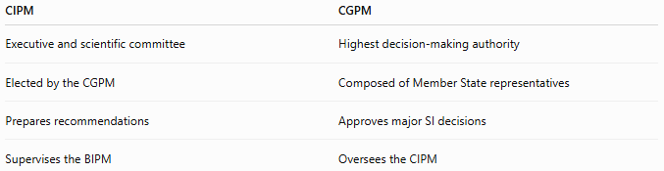
CIPM | CGPM
Executive and scientific committee | Highest decision-making authority
Elected by the CGPM | Composed of Member State representatives
Prepares recommendations | Approves major SI decisions
Supervises the BIPM | Oversees the CIPM

CIPM vs. BIPM
# Source: AI Source: Provided by: [Data Path: Persons Table -> ID Column: 1, Name_En Column: Motasem Essam] -> From: [ChatGPT] on [7/17/2026]
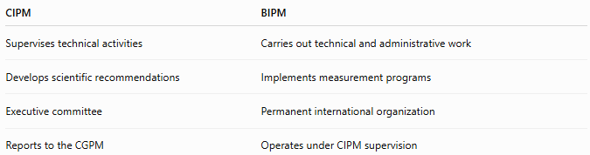
CIPM | BIPM
Supervises technical activities | Carries out technical and administrative work
Develops scientific recommendations | Implements measurement programs
Executive committee | Permanent international organization
Reports to the CGPM | Operates under CIPM supervision

CIPM vs. National Metrology Institutes
# Source: AI Source: Provided by: [Data Path: Persons Table -> ID Column: 1, Name_En Column: Motasem Essam] -> From: [ChatGPT] on [7/17/2026]
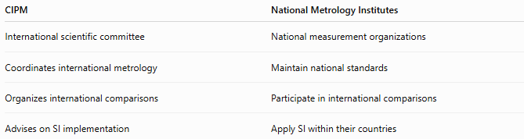
CIPM | National Metrology Institutes
International scientific committee | National measurement organizations
Coordinates international metrology | Maintain national standards
Organizes international comparisons | Participate in international comparisons
Advises on SI implementation | Apply SI within their countries

Organizational Structure
# Source: AI Source: Provided by: [Data Path: Persons Table -> ID Column: 1, Name_En Column: Motasem Essam] -> From: [ChatGPT] on [7/17/2026]
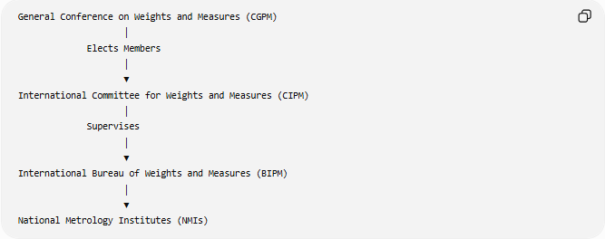
General Conference on Weights and Measures (CGPM)
│
Elects Members
│
▼
International Committee for Weights and Measures (CIPM)
│
Supervises
│
▼
International Bureau of Weights and Measures (BIPM)
│
▼
National Metrology Institutes (NMIs)

Conclusion
# Source: AI Source: Provided by: [Data Path: Persons Table -> ID Column: 1, Name_En Column: Motasem Essam] -> From: [ChatGPT] on [7/17/2026]
The International Committee for Weights and Measures (CIPM) is the executive and scientific committee established by the Metre Convention to supervise the BIPM and guide the development of the International System of Units (SI) between meetings of the CGPM. By coordinating international comparisons, overseeing consultative committees, promoting measurement traceability, and preparing scientific recommendations, the CIPM plays a central role in ensuring that measurements around the world remain accurate, consistent, and internationally recognized.

